BrainBeats: an open-source EEGLAB plugin to jointly analyze EEG and cardiovascular (ECG/PPG) signals

Cédric Cannard1,2, Helané Wahbeh2, Arnaud Delorme1,2,3

1 Centre de Recherche Cerveau et Cognition (CerCo), CNRS, Toulouse III University, France

2 Institute of Noetic Sciences (IONS), Novato, California, USA.

3 Swartz Center of Computational Neuroscience (SCCN), INC, UCSD, La Jolla, USA

**KEYWORDS:** open-source, EEGLAB, EEG, ECG, PPG, HRV, feature-analysis, heartbeat-event potentials/oscillations (HEP/HEO), heart component removal.

**SUMMARY:** The BrainBeats toolbox is an open-source EEGLAB plugin designed to jointly analyze EEG and cardiovascular (ECG/PPG) signals. It offers three main protocols: heartbeat-evoked potentials assessment, feature-based analysis, and heart artifact extraction from EEG. This will aid researchers and clinicians in studying brain-heart interactions with enhanced reproducibility and accessibility.

**ABSTRACT:** The link between the cortical and cardiovascular systems is garnering increased attention due to its potential to offer valuable insights into brain and heart function coupling. Current joint analysis methodologies largely involve invasive or high-cost neuroimaging methods. EEG and ECG/PPG, however, provide non-invasive, cost-effective, and portable alternatives enabling broader data collection in both laboratory and clinical settings. However, the analysis of these biosignals is challenging for scalable applications due to their complex nature. Existing research and tools often lack consensus in processing and statistical methodologies, easy-to-use user interface, or batch processing capacity of large datasets, impeding reproducibility. A further void exists in standardized methods for EEG and heart-rate variability (HRV) feature extraction, undermining clinical diagnostics or the robustness of machine learning models. We introduce the BrainBeats toolbox in response to these challenges, an open-source EEGLAB plugin providing an suite of signal processing and feature-extraction functions adhering to current guidelines and recommendations. The toolbox integrates three main protocols: 1) Heartbeat-evoked potentials (HEP) and oscillations (HEO); 2) EEG and HRV feature extraction; 3) Automated removal of heart artifacts from EEG signals. Accompanied by sample data and guidance, BrainBeats aims to facilitate brain-heart interplay research and reproducibility. This open-source toolbox offers a valuable resource for clinicians and researchers studying brain-heart interactions and can be tailored to unique research needs.

**INTRODUCTION:**

The purpose of this method is to ease the investigation of relationships between the brain and the heart by facilitating the joint analysis of electroencephalography (EEG) and cardiovascular signals, namely electrocardiography (ECG) and photoplethysmography (PPG) while implanting the latest guidelines from experts in this field. This tool addresses limitations from existing methods and is made open source to facilitate accessibility and reproducibility in the area. The proposed toolbox should serve as a valuable resource for researchers and clinicians interested in removing cardiac artifacts from EEG signals, extracting features from EEG and ECG/PPG signals, or studying the relationship between brain and cardiovascular activity. Ultimately, this toolbox aims to pave the way for more in-depth investigations into the complex interplay between the brain and heart systems.

For a long time, the reductionist approach has dominated scientific inquiry in human physiology and cognition. This approach involved dissecting complex bodily and mental processes into smaller, more manageable components, allowing researchers to focus on individual systems in isolation. This strategy arose due to the immense challenge of studying the intricate and interconnected nature of the human body and mind1. Reductionism has been instrumental in understanding individual subsystems in isolation, such as elucidating the role of ion channels and action potentials for neural2 and cardiac3 communication. However, a significant gap remains in understanding how these isolated systems interact on a larger spatial and temporal scale. The multimodal (also termed integrative or ecological) approach considers the human body as a collective, a living being which uses the brain to mediate interactions (within the body and between the body and its environment)4. “Within this framework, the mind is seen not as a product of the brain but as an activity of the living being; an activity which integrates the brain within the everyday functions of the human body.”4 The multimodal and reductionist approaches are not exclusive, jus tlike we cannot study one neuron without the whole brain, or the wole brain without understanding individual neuron properties. Together, they pave the way for a more comprehensive understanding of human health, pathology, cognition, and consciousness, offering novel insights into the synergistic and nonlinear mechanisms between the human body and mind4–6.

**Heart-brain research: which measures?**

Studying the intricate relationship between the brain and the heart can yield valuable insights into the underlying physiology and anatomy of the human body, ultimately leading to the development of novel diagnostic and therapeutic tools. The relationship between the heart and the brain has been studied via neuroimaging methods such as functional magnetic resonance imaging (fMRI) and positron emission tomography (PET). Using these tools, researchers highlighted some brain regions associated with cardiovascular control (e.g., manipulation of heart rate and blood pressure7,8), showed the influence of heart rate on the BOLD signal9,10, or identified potential brain-body pathways contributing to coronary heart disease (i.e., stress-evoked blood pressure11).

While these studies have significantly advanced our understanding of the complex interplay between the central nervous system (CNS) and cardiovascular function, these neuroimaging techniques are expensive, have limited availability, and are confined to controlled laboratory settings, which restricts their practicality for real-world and large-scale applications. In contrast, EEG and ECG/PPG are more affordable and portable tools that offer the potential for studying brain-heart interactions in more diverse settings and populations or over longer periods, providing new opportunities for investigating the dynamic relationship between brain and heart function. ECG measures the electrical signals generated by the heart when it contracts and relaxes via electrodes placed on the skin (usually on the chest, arms, or legs). PPG measures blood volume changes in the microvascular tissues using a light source (e.g., LED) and a photodetector placed on the skin (commonly on a fingertip, earlobe, or forehead). Since blood absorbs more light than the surrounding tissue, the PPG signal can be used to estimate blood flow and pulse rate. Both methods provide valuable information about cardiovascular function but serve different purposes and offer distinct data types. As such, the use of EEG and ECG/PPG holds great promise for advancing our understanding of the physiological, cognitive, and emotional processes underlying brain-heart interactions and their implications for human health and well-being. Like ECG, EEG records the electrical fields generated by the synchronized activity of thousands of cortical neurons by placing electrodes on the scalp.

**The two approaches for jointly analyzing these signals**

There are two main approaches to studying interactions between EEG and cardiovascular signals:

1. The heartbeat-evoked potentials (HEP) for the time domain (i.e., ERP) and heartbeat-evoked oscillations (HEO) for the time-frequency domain (i.e., event-related spectral perturbations). This approach examines how the brain processes cardiovascular activity with millisecond accuracy and requires that both time series are time-locked, the heartbeats be marked with events in the EEG signals, and the heart signal removed. This approach is the most popular12–30.
2. Feature-based: this approach extracts EEG and heart-rate variability (HRV) features from continuous signals and examines associations between them. This has been done with ECG31–33 and PPG to a lesser extent, to our knowledge34–36. This approach presents promising applications by capturing both the state-related and trait-related variables. Note that, for both EEG and cardiovascular signals, the longer the recording, the more dominant the trait variable37–39. Thus the applications depend on the recording parameters. Feature-based analyses (including qEEG or feature-based machine learning) are growing in interest for both clinicians and scholars, providing new objective metrics for making early predictions/forecasting of the development of mental and neurological disorders, of treatment-response, or of relapse40–48. This approach is especially compelling with large datasets and real-world settings (e.g., clinic, remote monitoring), which can be more easily obtained thanks to the recent innovations in wearable neurotechnology49.

**The advantages over alternative methods**

While many tools exist to process cardiovascular and EEG, and HRV signals independently from one another, none is currently available for jointly analyzing them. Furthermore, the tools available to process cardiovascular signals require expensive license purchase, do not allow processing large datasets in batch via command line, have proprietary algorithms that limit reproducibility, or require advanced programming skills by not providing a graphical user interface (GUI). To our knowledge, three open-source MATLAB toolboxes exist to support HEP analysis with a GUI. The *ecg-kit* toolbox50, the *HEPLAB* EEGLAB plugin51, and the *CARE-rCortex* toolbox52. While *HEPLAB* and *ecg-kit* facilitate HEP analysis by detecting heartbeats and marking them in the EEG signals, they do not provide statistical tools for analysis and are limited to the time domain (i.e., ERP). The *CARE-rCortex* pluginaddressed these issues by supporting ECG and respiratory signals, time-frequency domain analysis, statistics, and advanced baseline normalization and correction methods adapted to HEP analysis. However, it uses the Bonferroni method for multiple comparison correction, which is too conservative for the many comparisons in EEG analysis and the assumption about independence (across electrodes, time points or frequency bins), leading to an increase in type II53. Furthermore, the toolbox does not offer command-line access for processing and analyzing large datasets for advanced users. Finally, recent studies recommend against baseline correction methods, as they reduce the signal-to-noise ratio (SNR) and are "statistically unnecessary and undesirable"54–56.

To address these limitations, we introduce the *BrainBeats* Matlab toolbox, implemented as an open-source EEGLAB plugin designed to process and analyze EEG and ECG/PPG signals jointly. It incorporates the following advantages over previous methods:

I) An easy-to-use GUI (for non-programmers) and command line mode (for programmers aiming to perform automated processing and analysis on large datasets using more advanced parameters).

II) Implementation of validated algorithms, parameters, and guidelines for processing cardiovascular signals, such as detecting R peaks, interpolating RR artifacts, and computing HRV metrics (e.g., implanting guidelines for windowing, resampling, normalization, etc.37,57,58). This is important because Vest et al. (2018) demonstrated how modest differences in these processing steps can lead to divergent results, contributing to the lack of reproducibility and clinical applicability of HRV metrics.

III) Implementation of validated algorithms, parameters, and guidelines for processing EEG signals, including re-referencing to infinity when at least 30 channels are available 59–63, removal of abnormal channels and artifacts64–66, interpolation of removed channels67, optimized parameters for ICA decomposition and classification of independent components68–71, guidelines filtering windowing and parameters56,72–74. Note: users can also use the toolbox with processed data and turn off processing steps.

IV) Heartbeat-evoked potentials (HEP, i.e., time domain) and oscillations (HEO; event-related spectral perturbations with wavelet or FFT methods, and inter-trial coherence are available). Advanced statistics, including hierarchical linear modeling75, which accounts well for within and between-subjects variance, with weighted least square optimization to downweigh remaining artifactual trials (WLS76). Nonparametric statistics include permutation statistics and spatiotemporal corrections for multiple comparisons77,78. Note: statistical analyses can also be performed in the independent component domain.

V) Supports the joint extraction of EEG and HRV features for the first time. These features can be analyzed separately (direct differences between groups/conditions, or associations with third variables) and jointly (same but from correlation coefficients). See above for applications.

VI) The toolbox provides various data visualizations to inspect signals at various necessary processing steps and outputs at the subject level (see Representative results for illustration).

**Information to help readers decide whether the method is appropriate for them**

This toolbox is appropriate for any researcher or clinician with EEG and ECG/PPG data. The plugin does not yet support importing EEG and ECG/PPG signals from separate files (although this feature will be available soon). The toolbox is appropriate for anyone aiming to perform HEP/HEO analysis, extract EEG and/or HRV features with standardized methods, or simply remove heart artifacts from EEG signals.

**PROTOCOL**

1. **Method 1: Heartbeat-evoked potentials (HEP)**
   1. Load data into EEGLAB: *File > Load existing dataset > select "sample_data1.set"*. See **Figure 1.1.** Note: this dataset was collected with a "wet" Biosemi system during a mind-wandering (shortened to 5 minutes to facilitate replication of the following steps) with 64 EEG channels and 2 ECG channels.

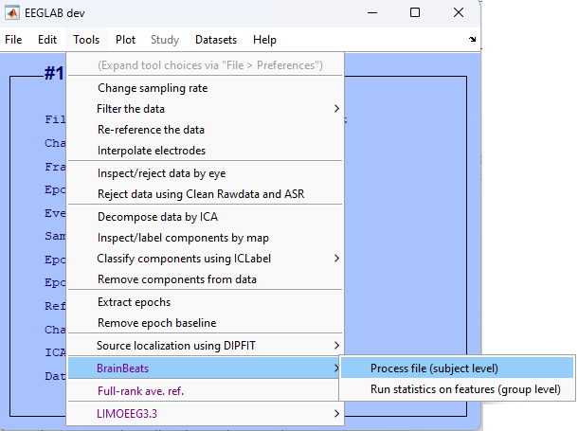

Figure 1.1. Main EEGLAB menu to launch BrainBeats' general user interface (GUI) to select processing parameters.

* 1. Open the general user interface (GUI) to select parameters: Tools > BrainBeats > Process file (subject level).
  2. Select "Heartbeat-evoked potentials HEP" as analysis to run, "ECG" as heart data type, click on the button to display the list of channels to select the ECG channels labeled "ECG1" and "ECG2" (or type the channel labels directly in the text box next to the button. Select "Shape-preserving piecewise cubic interpolation" as the cleaning method of RR artifacts and clean EEG data. Select "Clean EEG" to process the EEG data, plot and save outputs, and click "Ok" to launch. See the overview in **Figure 1.2**. All steps are automated (see **Representative Results**).

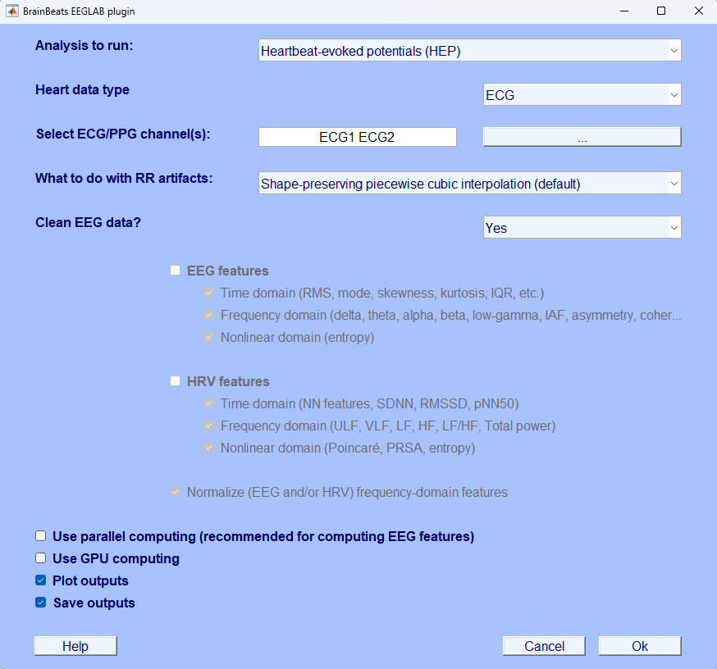

Figure 1.2. Using the GUI to select parameters for preparing data for heartbeat-evoked potentials (HEP) analysis.

Advanced users can perform all the above steps with the following command lines:

eeglab; close;

mainDir = fileparts(which('eegplugin_BrainBeats.m')); cd(mainDir);

EEG = pop_loadset('filename','sample_data1.set','filepath',fullfile(mainDir, 'sample_data'));

EEG = brainbeats_process(EEG,'analysis','hep','heart_signal','ECG', ...

'heart_channels',{'ECG1' 'ECG2'},'clean_rr','pchip','clean_eeg',true, ...

'parpool',false,'gpu',false,'vis',true,'save',true);

1. **METHOD 2: Extract EEG and HRV features from continuous data**
   1. Load the dataset and launch the BrainBeats GUI as for METHOD 1. Select "Extract EEG & HRV features from continuous data", the same parameters for ECG channels, RR interpolation method, and "clean EEG". Notice that the EEG and HRV feature fields are now unlocked. Check both to extract EEG and HRV features. All domains (time, frequency, nonlinear) are set by default. Check "Use parallel computing" to increase computation speed. "Plot and save outputs" are set by default. Click "Ok" to launch.

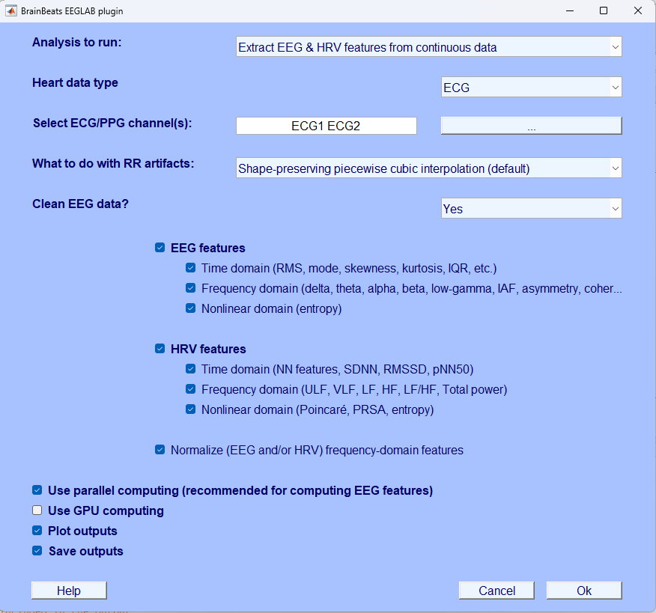

Figure 2.1. BrainBeats GUI to select parameters for extracting HRV and EEG features from continuous data.

Advanced users can perform all steps above with the following command:

eeglab; close;

EEG = pop_loadset('filename','sample_data2.set','filepath',fullfile(dataDir, 'sample_data'));

mainDir = fileparts(which('eegplugin_BrainBeats.m')); cd(mainDir);

[~, Features] = brainbeats_process(EEG,'analysis','features','heart_signal','ECG', 'heart_channels',{'ECG1' 'ECG2'}, 'clean_rr','pchip','clean_eeg',true,'norm',true,...

'eeg_features', {'time' 'frequency' 'nonlinear'}, ...

'hrv_features', {'time' 'frequency' 'nonlinear'}, ...

'gpu',false,'parpool',true,'save',true,'vis',true);

1. **Method 3: Remove heart components from EEG signals.**
   1. Load "sample_data2.set" containing 3 EEG channels and one ECG channel, collected with a "dry" Muse wearable headset.

Open the same BrainBeats GUI (see **Step 1.1**. and **Figure 1.1.**) and set the analysis type as "Remove heart components from EEG signals", and select the ECG channel from the list of channels. Select "No (already processed)" in the "Clean EEG?" field since this sample file was already preprocessed. Set "Plot outputs" and "Save outputs" options (set by default). Click "Ok" to launch.

These steps can be run automatically over many files using the following command lines:

eeglab; close; mainDir = fileparts(which('pop_BrainBeats.m')); cd(mainDir);

EEG = pop_loadset('filename','sample_data2.set','filepath',dataDir);

EEG = brainbeats_process(EEG,'analysis','rm_heart','heart_signal','ECG', ...

'heart_channels',{'ECG'},'clean_eeg',false,'save',true,'vis',true);

As for Method 1, users can perform statistical analyses using the EEGLAB STUDY mode. Users can perform basic statistical analyses in EEGLAB (e.g., permutation statistics, FDR-correction), or advanced hierarchical linear modeling with weighted-least square (WLS) optimization, to better account for within and between subject variance, using the LIMO-EEG plugin. Furthermore, the plugin provides advanced corrections for type 1 error (e.g., max likelihood or spatiotemporal cluster corrections).

**REPRESENTATIVE RESULTS:**

**METHOD 1**

BrainBeats first separates the ECG from EEG data to process them separately. EEG data are bandpass filtered using a zero-phase non-causal finite impulse response (FIR) filter to remove low-frequency drifts and high-frequency noise (highpass cutoff frequency = 1 Hz, low-pass cutoff = 45; transition bandwidth = 0.5 Hz). If the data have at least 30 channels and have not been referenced, BrainBeats re-references them to infinity. Then, BrainBeats uses the *clean_rawdata* plugin to automatically detect and remove abnormal EEG channels (flatlinecriterion = 5; ChannelCriterion = .8; LineNoiseCriterion = 5). Removed channels are plotted (**Figure 1.3, in red**) and interpolated using spherical splines (Perrin et al., 1989). CAUTION: These default parameters are implemented for the best performance for this sample dataset. In most cases, we recommend users clean their datasets before launching BrainBeats to tune parameters for their datasets. For example, abnormal channels may not be reliably detected on low-density EEG montages using this default method.

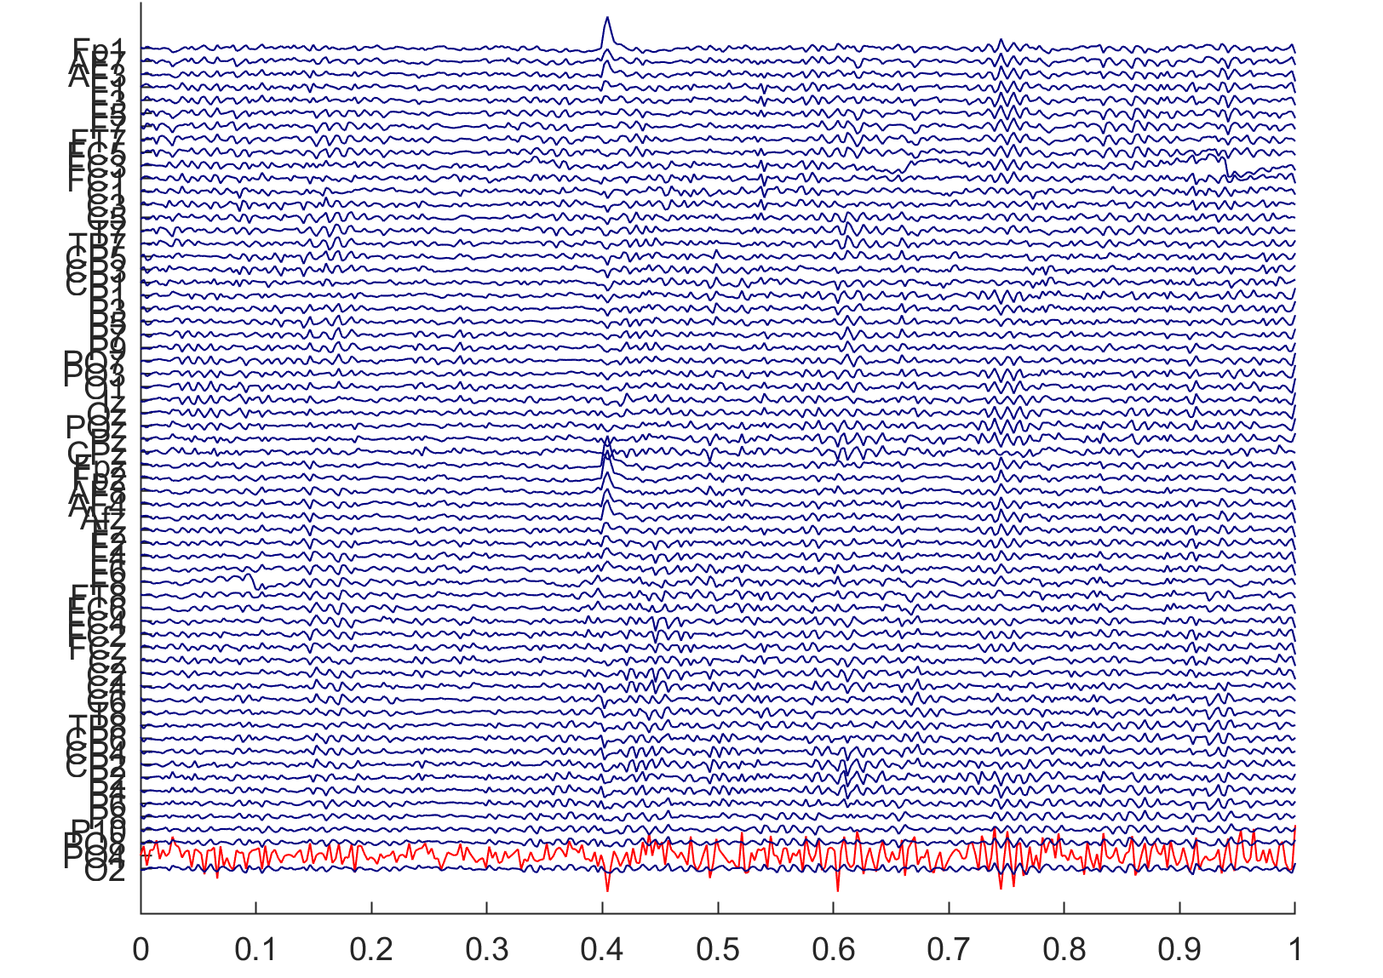

Figure 1.3. Abnormal EEG channels are automatically detected and removed by BrainBeats (in red).

Next, BrainBeats detects R-peaks (from QRS complexes) on non-overlapping windows disregarding initial signal artifacts. The signal undergoes bandpass filtering and Pan–Tompkins (P&T) method79, including differentiation, squaring, integration, and smoothing. The P&T energy threshold is estimated to avoid disruption from large bumps, and if the RR interval variability exceeds 1.5 times the median, it conducts a "search back" for missed peaks. The R-peak's mean sign over 30 seconds determines the QRS complex sign, ensuring consistent detection. QRS detection and search back are based on an energy threshold defined by the signal's sample rate and smoothed ECG values. Each segment's peak sign is ascertained, and peak points are refined through a refractory period check, also managing flatline conditions. The output consists of RR intervals, heart rate (HR), RR interval timestamps, filtered signal, R-peak indices, peak sign, and the estimated P&T energy threshold.

Next, BrainBeats identifies abnormal RR intervals (e.g., too closely or broadly spaced, physiological and non-physiological artifacts), flag them, and interpolates them using the shape-reserving piecewise cubic method (default) to obtain the normal-to-normal (NN) intervals. Spikes within RR intervals are detected using a forward-backward search. Users can choose another interpolation method or remove them if desired. When several ECG channels are present, these steps are performed on each of them, and the electrode with the least number of RR artifacts is selected for the following steps. The filtered ECG signal, identified R-peaks, NN intervals, and interpolated artifacts (from the best electrode) are plotted (see **Figure 1.4.**). Note that users can scroll through the R-peaks more closely using a scroll bar (30-s windows). This code is adapted from the validated algorithms developed for the Physionet Cardiovascular Signal toolbox58,80 (see reference for validation and performance comparison with other state-of-the-art algorithms).

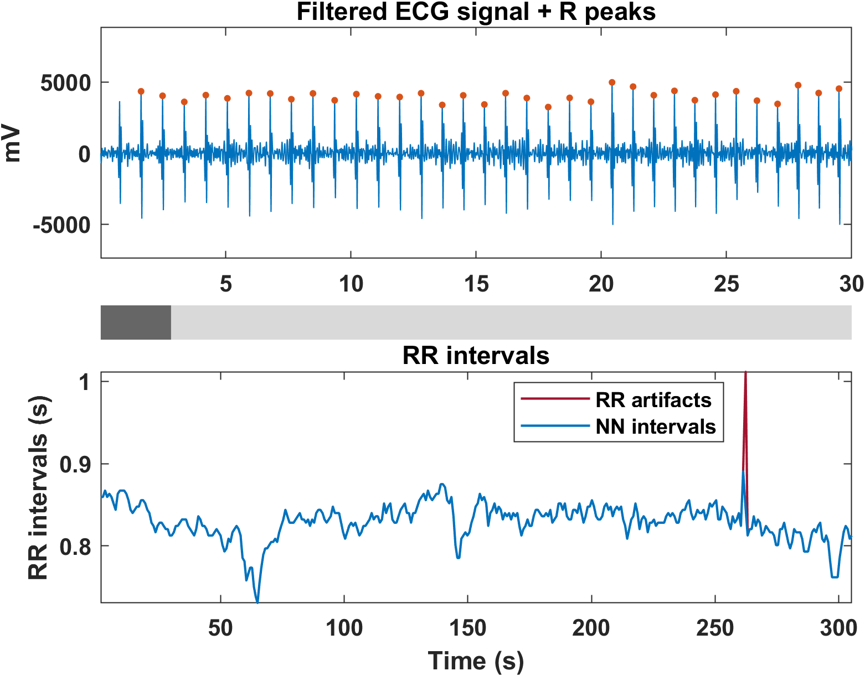

Figure 1.4. Filtered and smoothed ECG signal with identified R-peaks (top panel). Normal-to-normal (NN) intervals with the interpolated RR artifacts (bottom panel).

Next BrainBeats adds R-peak markers to the EEG signals, calculates inter-beat-intervals (IBIs), and removes trials with IBIs less than 550 ms (following recommendations63,81). The *run_HEP* function removes outlier trials (detected by MATLAB's *isoutlier* function, *'grubbs'* method from custom RMS and SNR metrics) and generates a histogram of the resulting IBIs with fitted normal density (see Figure 1.5.). To determine the minimum epoch size cutoff following R-peak events, the 5th percentile of the IBI data is calculated (i.e., the value below which 5% of the IBI falls, displayed as a dashed red line in the histogram). This epoch size maximizes the number of epochs and limits overlapping epochs.

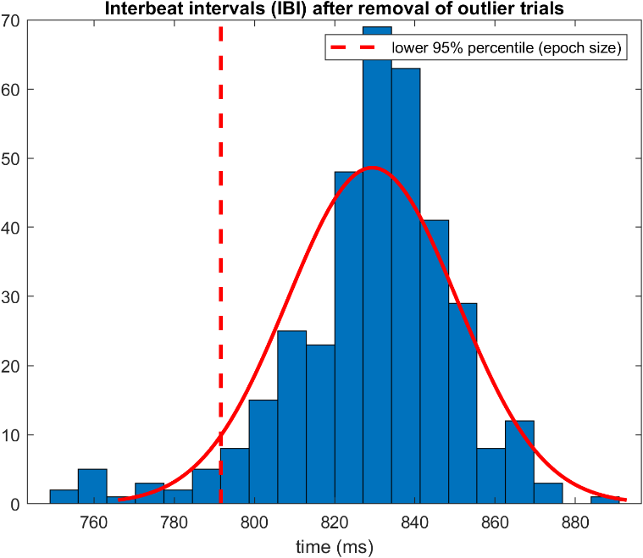

Figure 1.5. Histogram of the interbeat intervals (IBI) with fitted normal density (red line) and the 5% percentile (red dashed line) indicating the minimum cutoff value at which the EEG data are epoched.

BrainBeats then epochs the EEG data from -200 ms to + 5% percentile of IBI and eliminates abnormal trials (by extracting RMS and signal-to-noise ratio features for each epoch and identifying outliers) and eye/muscle components with ICA and ICLabel (at least 90% classification confidence for ocular components and 95% confidence for muscular components; see **Figure 1.6.**). These flagged components are then automatically subtracted from the EEG signals while preserving relevant brain signals. Note: if the Picard plugin is already installed in EEGLAB, it is used by default for fast computation of ICA, otherwise, the Infomax algorithm is used. Effective data rank is calculated prior to running ICA, and PCA-dimension reduction is applied when the data are rank-deficient to avoid ghost IC artifacts70. The final output of processed HEP data is plotted for final inspection (see **Figure 1.7.**) and saved in the same directory as the original file loaded by the user (same name with "_HEP" at the end). Note: it is recommended to follow the BIDS for better organization, replication, and performing statistics at the group level (EEGLAB STUDY). Users can pause before processing the next file (next condition or participant).

Figure 1.6. Indpendent component automatically classified and removed from HEP data to extract ocular artifacts without removing relevant brain signals.

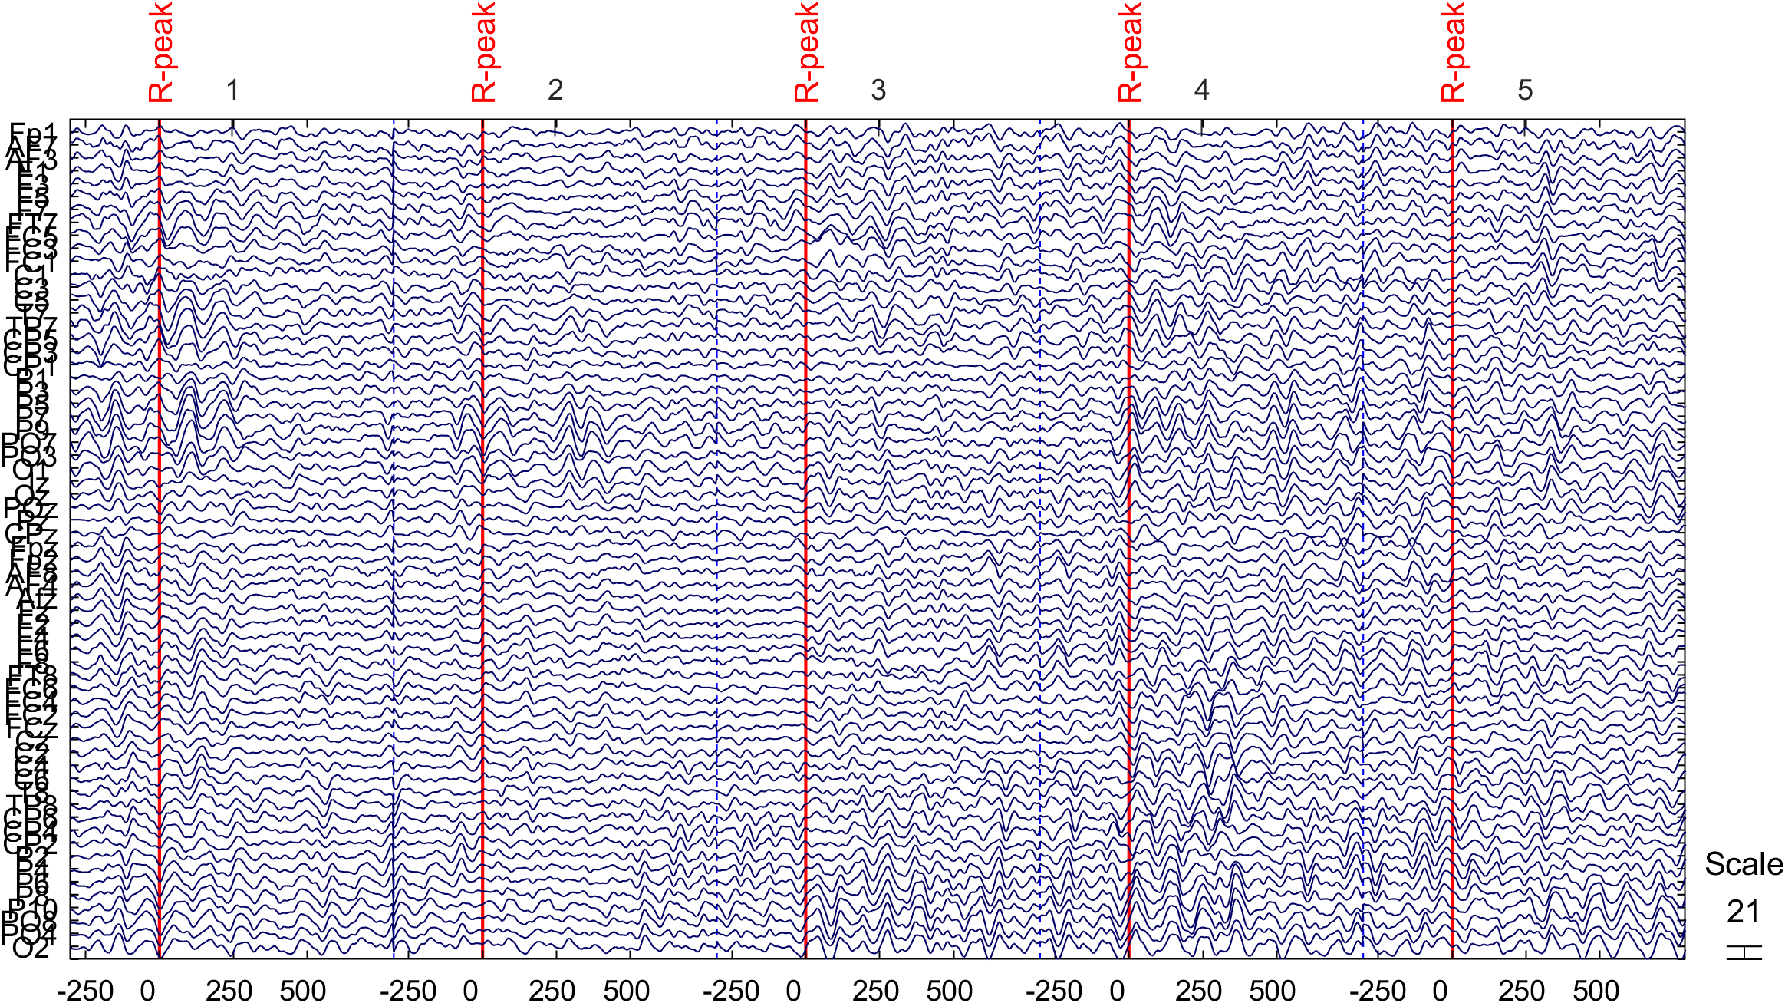

Figure 1.7. Final, cleaned EEG data, ready for HEP analysis.

The HEP averaged across all epochs are plotted as a scalp topography allowing users to inspect each electrode more closely (see Figure 1.8.), superimposed with scalp topography in the region of interest (200-500 ms after heartbeat; **Figure 1.9. top panel**), and the HEP evolution over time (**Figure 1.9. bottom panel**).

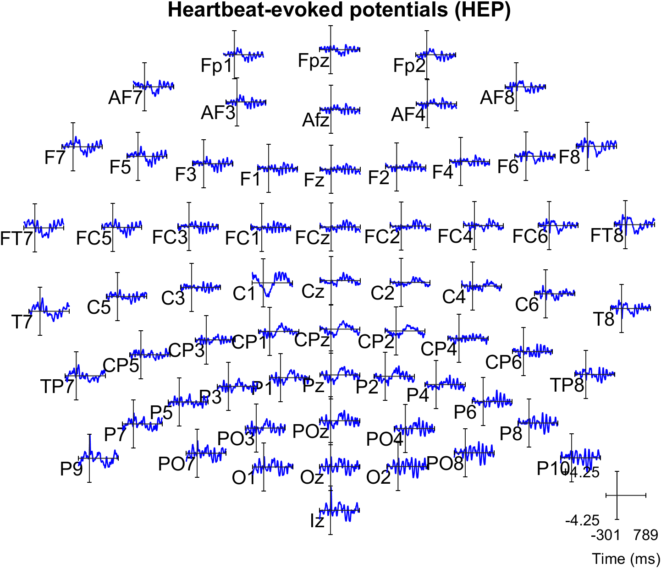

Figure 1.8. HEP averaged across trials for each electrode. Users can click on electrodes of interest for closer inspection.

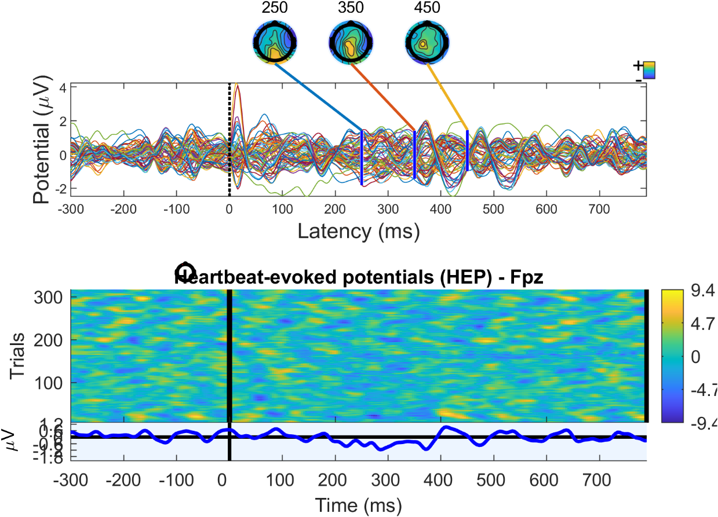

Figure 1.9. Top: HEP averaged across trials, all electrodes superimposed in the time domain, with scalp topographies showing amplitude distribution in the period of interest (200-500 ms after heartbeat). Bottom: HEP evolution over time (each "trial" corresponds to a heartbeat).

The heartbeat evoked oscillations (HEO, or event-related spectral perturbations; ERSP; **Figure 1.10. top panels**) and intertrial coherence (ITC; **Figure 1.10. bottom panels**) are computed for the frontal electrode Fpz using wavelet ([3 0.8] cycles; pre-event baseline removal; pad ratio of 2) for frequencies 7-30 Hz. The same plot is generated after applying permutation statistics and FDR correction to control for multiple comparisons (type 1 error or family-wise error). After correction (**Figure 1.10. Right**), a significant HEO effect is observed on the sample dataset in the beta band during the QRS complex (within 100 ms after R-peak) and in the alpha band during the period of interest (i.e., 200-500 ms, consistent with previous findings81,82). No effect is observed in the ITC data after correction. Note: these plots and results are for replication and illustration only. Low frequency cannot be estimated due to the short epoch size between the heartbeats.

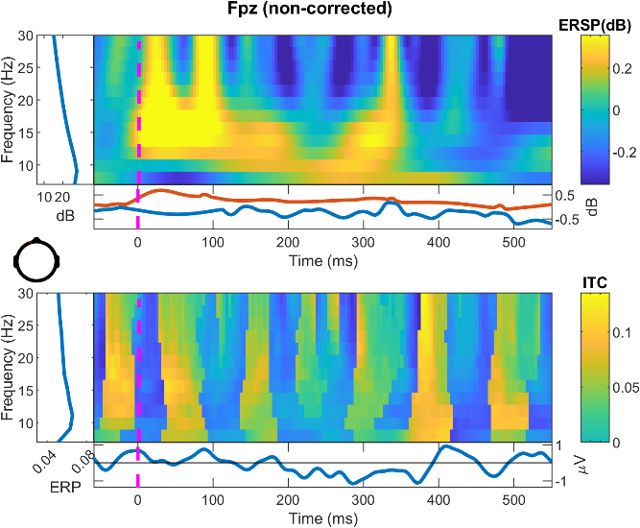 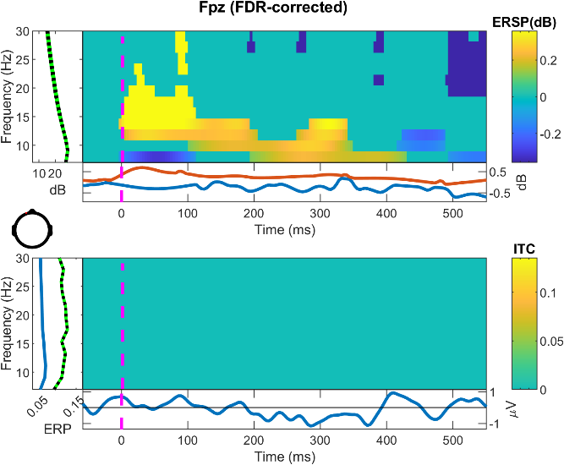

Figure 1.10. Heartbeat evoked oscillations (HEO) using event-related spectral perturbations (ERSP; i.e. wavelet; top panels) and inter-trial coherence (ITC) on the sample dataset (one subject). Left: uncorrected results; Right: results after permutation correction for type 1 error, showing an effect for ERSP but not ITC. Note: this is for illustration purpose only.

When all files are processed, users may import them into an EEGLAB STUDY to compute HEP (i.e., ERP) and HEO (i.e., ERSP and ITC) data on the whole group and run statistics at the group level. We recommend performing hierarchical linear modeling using the LIMO plugin75. A full tutorial is available at <https://github.com/LIMO-EEG-Toolbox/limo_tools/wiki>

METHOD 2

RR and NN series obtained as in METHOD 1 (The same **Figures 1.3.** and **1.4.** pop-up). However, EEG data are cleaned differently since EEG and ECG signals do not need to be time-locked with ms accuracy to extract features (unlike for HEP/HEO analysis). Here, instead of removing abnormal epochs, BrainBeats first removes segments with large EEG artifacts using artifact subspace reconstruction (ASR; SD criterion = 30; **Figure 2.1.**). Then, Infomax ICA (or the Picard algorithm if installed) is performed with PCA-dimension reduction to account for effective data rank, and ocular and muscular components are classified and subtracted from the signal using ICLabel (as in Method 1, but on continuous data). One ocular component is removed with 98.6% accuracy.

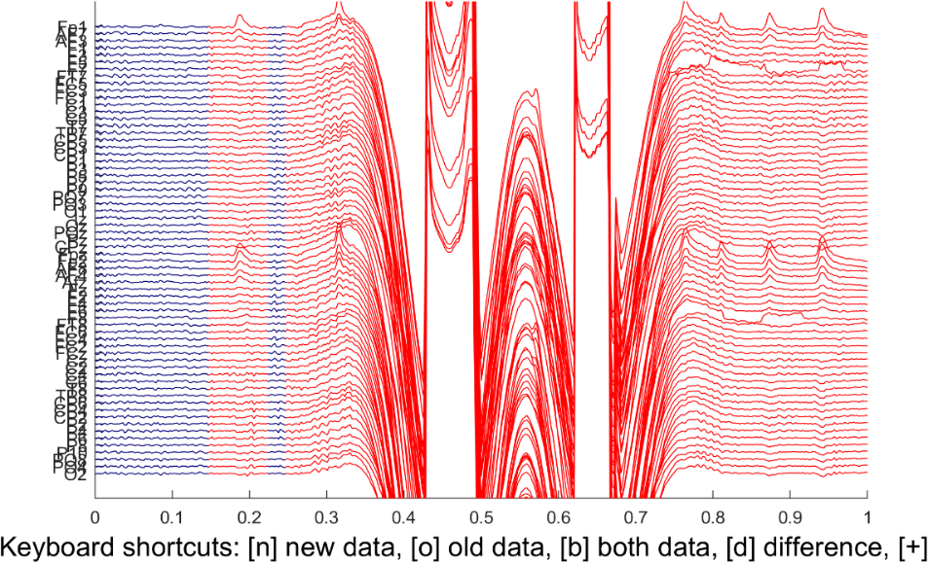

Figure 2.1. EEG artifacts are removed automatically from the continuous EEG data using artifact subspace reconstruction (ASR).

Then, HRV and EEG features are extracted in the time (NN), frequency, and nonlinear domains. See **Table 1** for a list of the features currently available. The Lombscargle-periodogram is the default method to compute frequency HRV as it does not require interpolation or resampling unlike the Welch or FFT methods, better preserving original information. The normalized periodogram is used by default to scale total power to the time series' variance, better dealing with non-uniformly sampled data (common in NN data), and facilitating comparison of results across different participants. When normalization is set in the GUI (default), each band power is divided by the total power to provide a more intuitive measure of the relative contribution of each band on overall power37. Note: the Welch and FFT methods, and the required resampling step are also available through command line. EEG spectral power is also normalized to decibels (dB) and to total power (same reasons as for HRV power). Additionally, an algorithm is used to detect individualized frequency bounds and compute band power on the individualized bands 83.

Table 1. HRV & EEG features estimated with the BrainBeats plugin

|  |  |  |
| --- | --- | --- |
|  | **HRV** | **EEG** |
| **Time** | NN statistics (mean, mode, variance, skewness, kurtosis, interquartile range), SDNN, RMSSD, pNN50. | Amplitude statistics (RMS, variance, skewness, kurtosis, interquartile range) |
| **Frequency** | Spectral power in the ultra-low frequency (ULF), very-low frequency (VLF), low-frequency (LF), and high-frequency (HF) bands, and total power. | Power spectra (all frequencies), mean band power (delta, theta, alpha, beta, low-gamma), individual alpha frequency (IAF), alpha asymmetry (all pairs), EEG coherence (between all non-neighbor pairs) |
| **Nonlinear** | Poincaré (SD1, SD2, SD1/SD2 ratio), fuzzy entropy, multiscale fuzzy entropy, phase-rectified signal averaging (PRSA) | Fuzzy entropy, multiscale fuzzy entropy (all scale factors, mean, SD, peak scale factor, and area under the curve) |

When features are computed, a plot displays the power spectral density (PSD) and multiscale fuzzy entropy (MFE) estimated on the NN series (**Figure 2.2., left**), and on the EEG data (the average across all electrodes is used for illustration; **Figure 2.2., Right**). For EEG MFE, each scale factor is bandpass filtered by default, following guidelines to reduce spectral bias in fine time scales (presumed to indicate fast dynamics) by broadband spectral power (dominated by low-frequency contributions84,85). As a result, the frequency bounds of each scale factors are provided. **Note**: EEG entropy measures are promising measures for capturing nonlinear dynamics between various body systems37,86–92, but they can be computation-heavy. Thus, 20 scale factors are set by default, and when EEG signals are longer than 5,000 samples, they are resampled (or decimated when the factor is not an integer) to 90 Hz (i.e., corresponding to a Nyquist frequency of 45 Hz, to match our default low-pass filter). Furthermore, parallel and/or GPU computing to further accelerate the process. The code is adapted from 88. The EEG scalp topographies are displayed for each frequency band (**Figure 2.3. top and middle rows**), as well as for the individual alpha frequency (IAF; **Figure 2.3. bottom left**) and fuzzy entropy (**Figure 2.3. bottom right**).

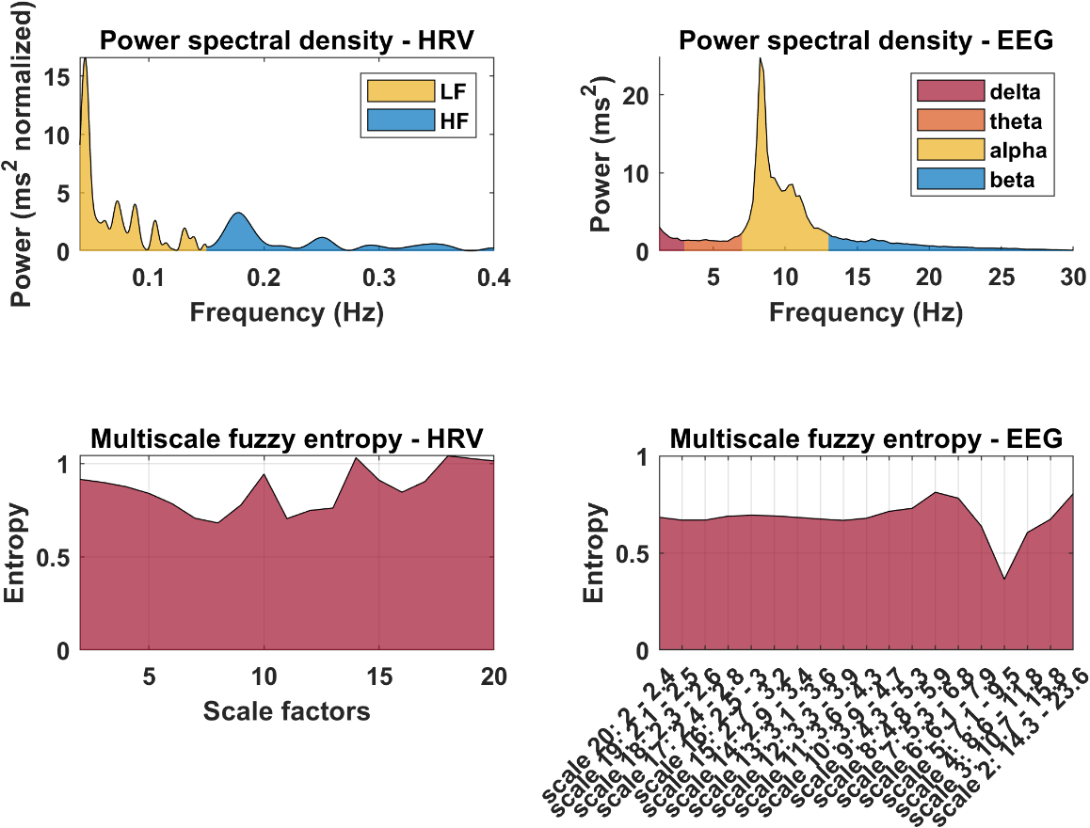

Figure 2.2. Power spectral density (PSD; top panel) and multiscale fuzzy entropy (MFE' bottom panels) features estimated from NN intervals (left panel) and EEG data (right panel). Note: calculated on the *sample_data1.set*, corresponding to 5 min of mindwandering eyes closed.

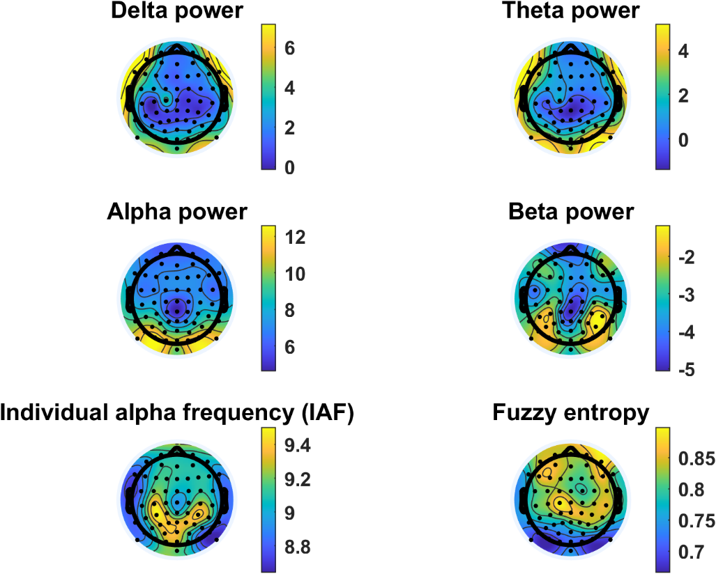

**Figure 2.3.** EEG scalp topographies showing the distribution of mean power spectral density (PSD) for the delta (top left), theta (top right), alpha (middle left), and beta (middle right) frequency bands. The individual alpha frequency (IAF) is plotted in the bottom left corner, and the fuzzy entropy distribution in the bottom right corner. Note: from *sample_data1.set*, corresponding of 5 min of mindwandering eyes closed.

**METHOD 3**

BrainBeats runs Infomax ICA (or Picard algorithm if installed) using PCA dimension-reduction to account for effective data rank (see above). Next, the heart component is automatically classified and removed with 95.3% confidence, using the ICLabel plugin. The ECG channel(s) is included in this process to increase ICA's source separation performance and chances to separate heart components from the EEG signals. Users can click on the component to inspect its properties in more detail (see **Figure 3.1. left**). The final output is displayed, showing the heart components removed from the EEG signals in red (**Figure 3.1. right**). Notes: The ECG signal is included here only for visualization purposes, but is otherwise removed from the output dataset. When no heart components are detected, users are informed in MATLAB's command window, and the program ends.

**Figure 3.1.** **Left**: Heart independent component classified by ICLabel and its properties. **Right**: EEG signals after removing the heart artifacts (in red). The ECG signal is included here for visualization purposes, but is otherwise removed from the final output dataset.

**DISCUSSION:**

**Critical steps in the protocol**

Critical steps prior to launching Brainbeats include: having MATLAB and EELAB installed, installing the BrainBeats plugin, installing a few EEGLAB plugins (for Methods 1 and 3), possessing a dataset that includes both EEG and cardiovascular (ECG or PPG) signals and importing with appropriate EEGLAB plugin, knowing the name of the cardiovascular channel(s) to select from the list, selecting initial parameters in the main GUI. Note that, data importation cannot be automated as various plugins are required to be installed to account for the many different EEG data formats that exist (e.g., .edf, .bdf, .vhdr, etc.).

Warnings and error messages are implemented at various places in the toolbox to help users understand why they may encounter issues (e.g., file length being too short for calculating a reliable measure of ultra-low frequency HRV, signal quality being too low for any reliable analysis, missing electrode locations etc.).

Note that for advanced users, each function contains a brief description of what it does and what the parameters are (and default, recommended parameters), which can be displayed in the command window by calling "help function_name".

**Limitations of the method**

Entropy features are particularly promising for capturing complex, bidirectional interactions between cardiovascular, subcortical, and cortical systems that may be hidden in nonlinear feedback loop dynamics37,86–92. However, they are very computationally heavy and can take a very long time to compute on EEG signals. While improvements were made (parallel computing, GPU computing, signal downsampling/decimation), further accelerations are required, if possible. While statistics are provided for the Method 1 and 3 (at the subject and group levels using the EEGLAB STUDY mode), no statistical analysis is currently provided for Method 2, to assess interactions between HRV and EEG features. This is because a lot of flexibility must be implemented to account for the various analyses users may want to perform (e.g., statistics, machine learning). However, users may use the Method 2 to extract features and easily perform statistics with any standard statistical software.

Users cannot import EEG and ECG/PPG data from separate files yet (although this feature will be available soon).

**Significance of the method with respect to existing methods**

Overall, BrainBeats provides state-of-the-art signal processing techniques and statistical methods for both EEG and cardiovascular signals, that are superior to currently available tools. Method 1 can be performed using advanced hierarchical linear modeling and statistical testing, as well as analyzing brain-evoked response by heartbeats using both ERP, ERSP, and ITC measures, as well as channel (scalp signals from each electrode) and independent component (signals that are source-separated with ICA) domains. Method 2 does not have a pre-existing alternative currently. Method 3 allows quick and easy removal of heart components from the EEG signals, in a fully automated manner. While this already possible in EEGLAB, it requires users to perform a series of steps and choice of parameters (e.g., highpass filtering the signals, running ICA, running ICLabel, tuning parameters, subtracting the heart components from the EEG signals, and removing the ECG channels) that can easily lead to errors (e.g., ghost ICs70).

Additionally, the toolbox implements computing performance improvements to accelerate the estimation of EEG features (mainly multiscale entropy measures), including both GPU and parallel computing. Note that these options are only as beneficial as the users' hardware (i.e., graphic card and number of processors and threads).

**Future directions**

The toolbox will continue to be modified and improved by the authors in the long term, to implement the latest guidelines and recommendations by experts in the field, and fixing any errors that may arise.

Currently, users can extract features of interest and perform statistical analyses using their own methods (correlations, regressions, machine learning). However, BrainBeats will provide the following statistical methods for feature analysis soon:

1. Feature selection for HRV and EEG features using random forest (separately), to remove redundant and correlated features and reduce multiple comparisons.
2. Skipped correlations (Pearson or Spearman depending on data distribution and variance) will be performed across HRV and EEG features93,94, with FDR-correction for multiple comparisons to control for type 1 error 95.
3. Next, since correlation coefficients are non-normally distributed, they will be transformed using the Fisher r-to-z method to meet the normal distribution assumption of t-tests. Nonparametric tests (e.g., Wilcoxon signed-rank test and Wilcoxon rank-sum test) test for differences in central tendency and are not well-suited for differences in correlation coefficients, unlike t-tests. However, they will be used if N < 30.
4. If distributions are still significantly skewed, Yuen t-tests will be applied (using 20% trimmed means) to address the issue. If conditions/groups have different variance, a Welch t-test will be used.
5. If users do not wish to compare conditions or groups, but investigate associations between features and a third variable, or predict a response variable (e.g., age, sex, diagnosis, etc.), they will be able to do so using correlation matrices, simple/multiple linear regressions. Corrections for multiple comparisons will be implemented.

For HEP/HEO analysis, the short interbeat intervals (IBI) that occur naturally (~600-1000 ms) lead to short EEG epochs. While this is not an issue for HEP analysis in the time domain, it presents limitations for HEO analysis. Time-frequency decomposition requires data to extend up to 3 cycles in the lowest frequency of interest beyond the window of interest. For HEO, the window of interest being 200-500 ms, one would require for example an additional 600 ms before and after thw window (i.e., -400 to 900 ms) for examining frequencies as low as 5 Hz. This is strongly recommended for obtaining correct time and frequency resolution, and for avoiding edge effects. Thus, one would end up rejecting most trials since they would not have the required length (especially if one wanted to examine frequencies as low as 1 Hz an additional 3 s before and after window of interest). Hence, future developments will implement the ”reflection” method, which mirrors the signal from the window of interest (i.e. backward version of the signal) before and after to expand the available window. This provides smooth transitions and moves the edge effects further away. The mirrored sections are then removed.

Finally, other features and methods will be added to assess interactions between EEG and cardiovascular signals. New methods will include for example EEG-ECG coherence, the "time-resolved directional brain/heart interplay measurement"96, or classification of HEP or feature data using machine learning (e.g., decision trees, random forest, naïve bayes, SVM, KNN, long short-term memory networks, etc.)20.

**ACKNOWLEDGMENTS:**

Our research was supported in part by the Institute of Noetic Sciences.

**DISCLOSURES:**

The authors have nothing to disclose.

**REFERENCES:**

1. Bertalanffy, L. von. *General system theory : foundations, development, applications*. (G. Braziller, 1968).

2. Hodgkin, A. L. & Huxley, A. F. A quantitative description of membrane current and its application to conduction and excitation in nerve. *J. Physiol.* **117**, 500–544 (1952).

3. Bean, B. P. Nitrendipine block of cardiac calcium channels: high-affinity binding to the inactivated state. *Proc. Natl. Acad. Sci. U. S. A.* **81**, 6388–6392 (1984).

4. Fuchs, T. *Ecology of the Brain: The phenomenology and biology of the embodied mind*. (Oxford University Press, 2017).

5. Bunge, M. *Emergence and Convergence: Qualitative Novelty and the Unity of Knowledge*. (University of Toronto Press, 2003).

6. Thayer, J. F. & Lane, R. D. A model of neurovisceral integration in emotion regulation and dysregulation. *J. Affect. Disord.* **61**, 201–216 (2000).

7. Critchley, H. D., Corfield, D. R., Chandler, M. P., Mathias, C. J. & Dolan, R. J. Cerebral correlates of autonomic cardiovascular arousal: a functional neuroimaging investigation in humans. *J. Physiol.* **523**, 259–270 (2000).

8. Napadow, V. *et al.* Brain correlates of autonomic modulation: Combining heart rate variability with fMRI. *NeuroImage* **42**, 169–177 (2008).

9. Chang, C., Cunningham, J. P. & Glover, G. H. Influence of heart rate on the BOLD signal: The cardiac response function. *NeuroImage* **44**, 857–869 (2009).

10. Shmueli, K. *et al.* Low-frequency fluctuations in the cardiac rate as a source of variance in the resting-state fMRI BOLD signal. *NeuroImage* **38**, 306–320 (2007).

11. Gianaros, P. J. & Sheu, L. K. A review of neuroimaging studies of stressor-evoked blood pressure reactivity: Emerging evidence for a brain-body pathway to coronary heart disease risk. *NeuroImage* **47**, 922–936 (2009).

12. Schandry, R. Heart Beat Perception and Emotional Experience. *Psychophysiology* **18**, 483–488 (1981).

13. Couto, B. *et al.* Heart evoked potential triggers brain responses to natural affective scenes: A preliminary study. *Auton. Neurosci.* **193**, 132–137 (2015).

14. Al, E. *et al.* Heart–brain interactions shape somatosensory perception and evoked potentials. *Proc. Natl. Acad. Sci.* **117**, 10575–10584 (2020).

15. Antonacci, Y. *et al.* Investigating the Heartbeat-evoked cortical responses through parametric Time-Varying Information Measures. in *2022 12th Conference of the European Study Group on Cardiovascular Oscillations (ESGCO)* 1–2 (2022). doi:10.1109/ESGCO55423.2022.9931372.

16. Banellis, L. & Cruse, D. Skipping a Beat: Heartbeat-Evoked Potentials Reflect Predictions during Interoceptive-Exteroceptive Integration. *Cereb. Cortex Commun.* **1**, tgaa060 (2020).

17. Baranauskas, M., Grabauskaitė, A., Griškova-Bulanova, I., Lataitytė-Šimkevičienė, B. & Stanikūnas, R. Heartbeat evoked potentials (HEP) capture brain activity affecting subsequent heartbeat. *Biomed. Signal Process. Control* **68**, 102731 (2021).

18. Billeci, L. *et al.* Heartbeat-Evoked Cortical Potential during Sleep and Interoceptive Sensitivity: A Matter of Hypnotizability. *Brain Sci.* **11**, 1089 (2021).

19. Bogdány, T., Perakakis, P., Bódizs, R. & Simor, P. The heartbeat evoked potential is a questionable biomarker in nightmare disorder: A replication study. *NeuroImage Clin.* **33**, 102933 (2022).

20. Candia-Rivera, D. *et al.* Neural Responses to Heartbeats Detect Residual Signs of Consciousness during Resting State in Postcomatose Patients. *J. Neurosci.* **41**, 5251–5262 (2021).

21. Chang, E., Kim, H. T. & Yoo, B. Identifying physiological correlates of cybersickness using heartbeat-evoked potential analysis. *Virtual Real.* **26**, 1193–1205 (2022).

22. Fuseda, K. & Katayama, J. A new technique to measure the level of interest using heartbeat-evoked brain potential. *J. Psychophysiol.* **35**, 15–22 (2021).

23. Jiang, H. *et al.* Brain–Heart Interactions Underlying Traditional Tibetan Buddhist Meditation. *Cereb. Cortex* **30**, 439–450 (2020).

24. Immanuel, S. A. *et al.* Heartbeat Evoked Potentials during Sleep and Daytime Behavior in Children with Sleep-disordered Breathing. *Am. J. Respir. Crit. Care Med.* **190**, 1149–1157 (2014).

25. Kumral, D. *et al.* Attenuation of the Heartbeat-Evoked Potential in Patients With Atrial Fibrillation. *JACC Clin. Electrophysiol.* **8**, 1219–1230 (2022).

26. Lechinger, J., Heib, D. P. J., Gruber, W., Schabus, M. & Klimesch, W. Heartbeat-related EEG amplitude and phase modulations from wakefulness to deep sleep: Interactions with sleep spindles and slow oscillations. *Psychophysiology* **52**, 1441–1450 (2015).

27. Montoya, P., Schandry, R. & Müller, A. Heartbeat evoked potentials (HEP): topography and influence of cardiac awareness and focus of attention. *Electroencephalogr. Clin. Neurophysiol.* **88**, 163–172 (1993).

28. Pollatos, O. & Schandry, R. Accuracy of heartbeat perception is reflected in the amplitude of the heartbeat-evoked brain potential: Heartbeat-evoked potential and heartbeat perception. *Psychophysiology* **41**, 476–482 (2004).

29. Schmitz, M. *et al.* Heartbeat evoked potentials in patients with post-traumatic stress disorder: an unaltered neurobiological regulation system? *Eur. J. Psychotraumatology* **12**, 1987686 (2021).

30. Zwienenberg, L. *et al.* Heartbeat-Evoked Potential in Major Depressive Disorder: A Biomarker for Differential Treatment Prediction between Venlafaxine and rTMS? *Neuropsychobiology* 130–139 (2023) doi:10.1159/000529308.

31. Thayer, J. F., Åhs, F., Fredrikson, M., Sollers, J. J. & Wager, T. D. A meta-analysis of heart rate variability and neuroimaging studies: Implications for heart rate variability as a marker of stress and health. *Neurosci. Biobehav. Rev.* **36**, 747–756 (2012).

32. Mather, M. & Thayer, J. F. How heart rate variability affects emotion regulation brain networks. *Curr. Opin. Behav. Sci.* **19**, 98–104 (2018).

33. Kemp, A. H. & Quintana, D. S. The relationship between mental and physical health: Insights from the study of heart rate variability. *Int. J. Psychophysiol.* **89**, 288–296 (2013).

34. Daneshi Kohan, M., Motie Nasrabadi, A., Shamsollahi, M. B. & Sharifi, A. EEG/PPG effective connectivity fusion for analyzing deception in interview. *Signal Image Video Process.* **14**, 907–914 (2020).

35. Übeyli, E. D., Cvetkovic, D. & Cosic, I. Analysis of human PPG, ECG and EEG signals by eigenvector methods. *Digit. Signal Process.* **20**, 956–963 (2010).

36. Zambrana-Vinaroz, D., Vicente-Samper, J. M., Manrique-Cordoba, J. & Sabater-Navarro, J. M. Wearable Epileptic Seizure Prediction System Based on Machine Learning Techniques Using ECG, PPG and EEG Signals. *Sensors* **22**, 9372 (2022).

37. Shaffer, F. & Ginsberg, J. P. An Overview of Heart Rate Variability Metrics and Norms. *Front. Public Health* **5**, (2017).

38. Coan, J. A. & Allen, J. J. B. The state and trait nature of frontal EEG asymmetry in emotion. in *The asymmetrical brain* 565–615 (MIT Press, 2003).

39. Hagemann, D., Hewig, J., Seifert, J., Naumann, E. & Bartussek, D. The latent state-trait structure of resting EEG asymmetry: replication and extension. *Psychophysiol. 16364070* **42**, 740–52 (2005).

40. Widge, A. S. *et al.* Electroencephalographic Biomarkers for Treatment Response Prediction in Major Depressive Illness: A Meta-Analysis. *Am. J. Psychiatry* **176**, 44–56 (2019).

41. Olbrich, S. & Arns, M. EEG biomarkers in major depressive disorder: Discriminative power and prediction of treatment response. *Int. Rev. Psychiatry* **25**, 604–618 (2013).

42. Sheikhani, A., Behnam, H., Mohammadi, M. R., Noroozian, M. & Mohammadi, M. Detection of Abnormalities for Diagnosing of Children with Autism Disorders Using of Quantitative Electroencephalography Analysis. *J. Med. Syst.* **36**, 957–963 (2012).

43. Yasin, S. *et al.* EEG based Major Depressive disorder and Bipolar disorder detection using Neural Networks:A review. *Comput. Methods Programs Biomed.* **202**, 106007 (2021).

44. Kumar, Y., Dewal, M. L. & Anand, R. S. Epileptic seizures detection in EEG using DWT-based ApEn and artificial neural network. *Signal Image Video Process.* **8**, 1323–1334 (2014).

45. Acharya, U. R. *et al.* Automated diagnosis of epileptic EEG using entropies. *Biomed. Signal Process. Control* **7**, 401–408 (2012).

46. Adeli, H. & Ghosh-Dastidar, S. *Automated EEG-Based Diagnosis of Neurological Disorders: Inventing the Future of Neurology*. (CRC Press, 2010).

47. de Aguiar Neto, F. S. & Rosa, J. L. G. Depression biomarkers using non-invasive EEG: A review. *Neurosci. Biobehav. Rev.* **105**, 83–93 (2019).

48. Cannard, C., Wahbeh, H. & Delorme, A. Electroencephalography Correlates of Well-Being Using a Low-Cost Wearable System. *Front. Hum. Neurosci.* **15**, 736 (2021).

49. Cannard, C., Brandmeyer, T., Wahbeh, H. & Delorme, A. Self-health monitoring and wearable neurotechnologies. *Handb. Clin. Neurol.* **168**, 207–232 (2020).

50. Demski, A. J. & Soria, M. L. ecg-kit: a Matlab Toolbox for Cardiovascular Signal Processing. **4**, e8 (2016).

51. Perakakis, P. HEPLAB. (2023).

52. Grosselin, F., Navarro-Sune, X., Raux, M., Similowski, T. & Chavez, M. CARE-rCortex: A Matlab toolbox for the analysis of CArdio-REspiratory-related activity in the Cortex. *J. Neurosci. Methods* **308**, 309–316 (2018).

53. Luck, S. J. & Gaspelin, N. How to get statistically significant effects in any ERP experiment (and why you shouldn’t). *Psychophysiology* **54**, 146–157 (2017).

54. Alday, P. M. How much baseline correction do we need in ERP research? Extended GLM model can replace baseline correction while lifting its limits. *Psychophysiology* **56**, e13451 (2019).

55. Delorme, A. EEG is better left alone. *Sci. Rep.* **13**, 2372 (2023).

56. Widmann, A., Schröger, E. & Maess, B. Digital filter design for electrophysiological data – a practical approach. *J. Neurosci. Methods* **250**, 34–46 (2015).

57. Pham, T., Lau, Z. J., Chen, S. H. A. & Makowski, D. Heart Rate Variability in Psychology: A Review of HRV Indices and an Analysis Tutorial. *Sensors* **21**, 3998 (2021).

58. Vest, A. N. *et al.* An open source benchmarked toolbox for cardiovascular waveform and interval analysis. *Physiol. Meas.* **39**, 105004 (2018).

59. Yao, D. A method to standardize a reference of scalp EEG recordings to a point at infinity. *Physiol. Meas.* **22**, 693–711 (2001).

60. Yao, D. *et al.* A comparative study of different references for EEG spectral mapping: the issue of the neutral reference and the use of the infinity reference. *Physiol. Meas.* **26**, 173–184 (2005).

61. Yao, D. *et al.* Which Reference Should We Use for EEG and ERP practice? *Brain Topogr.* **32**, 530–549 (2019).

62. Dong, L. *et al.* MATLAB Toolboxes for Reference Electrode Standardization Technique (REST) of Scalp EEG. *Front. Neurosci.* **11**, 601 (2017).

63. Candia-Rivera, D., Catrambone, V. & Valenza, G. The role of electroencephalography electrical reference in the assessment of functional brain–heart interplay: From methodology to user guidelines. *J. Neurosci. Methods* **360**, 109269 (2021).

64. Mullen *et al.* Real-time Neuroimaging and Cognitive Monitoring Using Wearable Dry EEG. *IEEE Trans. Biomed. Eng. Spec. Issue Wearable Technol.* **62**, 2553–67 (2015).

65. Delorme, A. & Makeig, S. EEGLAB: an open source toolbox for analysis of single-trial EEG dynamics including independent component analysis. *J. Neurosci. Methods* **134**, 9–21 (2004).

66. Chang, C.-Y., Hsu, S.-H., Pion-Tonachini, L. & Jung, T.-P. Evaluation of Artifact Subspace Reconstruction for Automatic EEG Artifact Removal. in *2018 40th Annual International Conference of the IEEE Engineering in Medicine and Biology Society (EMBC)* 1242–1245 (2018). doi:10.1109/EMBC.2018.8512547.

67. Perrin, F., Pernier, J., Bertrand, O. & Echallier, J. F. Spherical splines for scalp potential and current density mapping. *Electroencephalogr Clin Neurophysiol* **72**, 184–7 (1989).

68. Ablin, P., Cardoso, J.-F. & Gramfort, A. Faster independent component analysis by preconditioning with Hessian approximations. *IEEE Trans. Signal Process.* **66**, 4040–4049 (2018).

69. Frank, G., Makeig, S. & Delorme, A. A Framework to Evaluate Independent Component Analysis applied to EEG signal: testing on the Picard algorithm. Preprint at http://arxiv.org/abs/2210.08409 (2022).

70. Kim, H. *et al.* ICA’s bug: How ghost ICs emerge from effective rank deficiency caused by EEG electrode interpolation and incorrect re-referencing. *Front. Signal Process.* **3**, (2023).

71. Pion-Tonachini, L., Kreutz-Delgado, K. & Makeig, S. ICLabel: An automated electroencephalographic independent component classifier, dataset, and website. *NeuroImage* **198**, 181–197 (2019).

72. Winkler, I., Debener, S., Müller, K.-R. & Tangermann, M. On the influence of high-pass filtering on ICA-based artifact reduction in EEG-ERP. *Annu. Int. Conf. IEEE Eng. Med. Biol. Soc. IEEE Eng. Med. Biol. Soc. Annu. Int. Conf.* **2015**, 4101–4105 (2015).

73. Smith, E. E., Reznik, S. J., Stewart, J. L. & Allen, J. J. B. Assessing and Conceptualizing Frontal EEG Asymmetry: An Updated Primer on Recording, Processing, Analyzing, and Interpreting Frontal Alpha Asymmetry. *Int. J. Psychophysiol. Off. J. Int. Organ. Psychophysiol.* **111**, 98–114 (2017).

74. Nunez, P. L. & Srinivasan, R. *Electric Fields of the Brain: The neurophysics of EEG*. (Oxford University Press, 2006). doi:10.1093/acprof:oso/9780195050387.001.0001.

75. Pernet, C. R., Chauveau, N., Gaspar, C. & Rousselet, G. A. LIMO EEG: A Toolbox for Hierarchical LInear MOdeling of ElectroEncephaloGraphic Data. *Comput. Intell. Neurosci.* **2011**, (2011).

76. Pernet, C. *et al.* Electroencephalography robust statistical linear modelling using a single weight per trial. *Aperture Neuro* **2022**, (2022).

77. Maris, E. & Oostenveld, R. Nonparametric statistical testing of EEG- and MEG-data. *J Neurosci Methods* **164**, 177–90 (2007).

78. Pernet, C. R., Latinus, M., Nichols, T. E. & Rousselet, G. A. Cluster-based computational methods for mass univariate analyses of event-related brain potentials/fields: A simulation study. *J Neurosci Methods* (2015) doi:10.1016/j.jneumeth.2014.08.003.

79. Pan, J. & Tompkins, W. J. A Real-Time QRS Detection Algorithm. *IEEE Trans. Biomed. Eng.* **BME-32**, 230–236 (1985).

80. Clifford, G. Signal processing methods for heart rate variability. (Oxford University, UK, 2002).

81. Park, H.-D. & Blanke, O. Heartbeat-evoked cortical responses: Underlying mechanisms, functional roles, and methodological considerations. *NeuroImage* **197**, 502–511 (2019).

82. Luft, C. D. B. & Bhattacharya, J. Aroused with heart: Modulation of heartbeat evoked potential by arousal induction and its oscillatory correlates. *Sci. Rep.* **5**, 15717 (2015).

83. Corcoran, A. W., Alday, P. M., Schlesewsky, M. & Bornkessel-Schlesewsky, I. *Towards a reliable, automated method of individual alpha frequency (IAF) quantification*. http://biorxiv.org/lookup/doi/10.1101/176792 (2017) doi:10.1101/176792.

84. Kosciessa, J. Q., Kloosterman, N. A. & Garrett, D. D. Standard multiscale entropy reflects neural dynamics at mismatched temporal scales: What’s signal irregularity got to do with it? *PLOS Comput. Biol.* **16**, e1007885 (2020).

85. Grandy, T. H., Garrett, D. D., Schmiedek, F. & Werkle-Bergner, M. On the estimation of brain signal entropy from sparse neuroimaging data. *Sci. Rep.* **6**, 23073 (2016).

86. Costa, M., Goldberger, A. L. & Peng, C.-K. Multiscale entropy analysis of biological signals. *Phys. Rev. E Stat. Nonlin. Soft Matter Phys.* **71**, 021906 (2005).

87. Klonowski, W. Everything you wanted to ask about EEG but were afraid to get the right answer. *Nonlinear Biomed. Phys.* **3**, 2 (2009).

88. Azami, H. & Escudero, J. Refined composite multivariate generalized multiscale fuzzy entropy: A tool for complexity analysis of multichannel signals. *Phys. Stat. Mech. Its Appl.* **465**, 261–276 (2017).

89. Humeau-Heurtier, A. Multiscale Entropy Approaches and Their Applications. *Entropy* **22**, 644 (2020).

90. Costa, M. D. & Goldberger, A. L. Generalized Multiscale Entropy Analysis: Application to Quantifying the Complex Volatility of Human Heartbeat Time Series. *Entropy Basel Switz.* **17**, 1197–1203 (2015).

91. Pincus, S. Approximate entropy (ApEn) as a complexity measure. *Chaos Woodbury N* **5**, 110–117 (1995).

92. Liu, C. *et al.* Analysis of heart rate variability using fuzzy measure entropy. *Comput. Biol. Med.* **43**, 100–108 (2013).

93. Pernet, C., Wilcox, R. & Rousselet, G. Robust Correlation Analyses: False Positive and Power Validation Using a New Open Source Matlab Toolbox. *Front. Psychol.* **3**, 606 (2013).

94. Wilcox, R. R., Rousselet, G. A. & Pernet, C. R. Improved methods for making inferences about multiple skipped correlations. *J. Stat. Comput. Simul.* **88**, 3116–3131 (2018).

95. Benjamini, Y. & Hochberg, Y. Controlling the False Discovery Rate: A Practical and Powerful Approach to Multiple Testing. *J. R. Stat. Soc. Ser. B Methodol.* **57**, 289–300 (1995).

96. Catrambone, V., Greco, A., Vanello, N., Scilingo, E. P. & Valenza, G. Time-Resolved Directional Brain–Heart Interplay Measurement Through Synthetic Data Generation Models. *Ann. Biomed. Eng.* **47**, 1479–1489 (2019).